B. Documents in Customer File

There are three main documents in the customer file that you need to study;
1. The New Client Info Sheet (yellow,)
2. The Survey Sheet (orange,)
3. The Table of Measurements (white, legal length.)
The New Client Info Sheet is the first document created when a potential customer calls the office. The estimator needs to be familiar with this document but never needs to enter info on this sheet. The Survey Sheet gives an overview of all services needed for the move. The estimator fills in most or all of the information on this sheet. The Table of Measurements is the tallying and totaling place for all furniture and cartons. This is the most detailed and important document. The estimator must know every section of this document in detail and fill it out with no errors.

After reading and studying this section find the TOM Speed test and practice completing this test until you can find every item in 3 seconds or less.

The New Client Info Sheet (Yellow)
As stated above, the estimator never needs to enter information on this sheet. This is the first document created when the customer calls Kearney Moving offices. The important sections for the estimator are in the right column. (see numbers on the diagram on the following page that correspond to the following explanations)

1. Left column sections include the Phone Script and the Service Process. The Phone Script is filled in by the office receptionist or the sales manager. The Service Process is the ‘tracking pipeline’ used to follow this customer through the sales process. It is filled in by the receptionist or sales manager.

2. Right Column name, address, phone, and call log. Before leaving for the estimate always check the client’s name, address and the call log. The call log sometimes contains notes important for the estimator to know, for example a request to bring cartons to the residence.

(see numbers on following diagram corresponding to the explanations above)

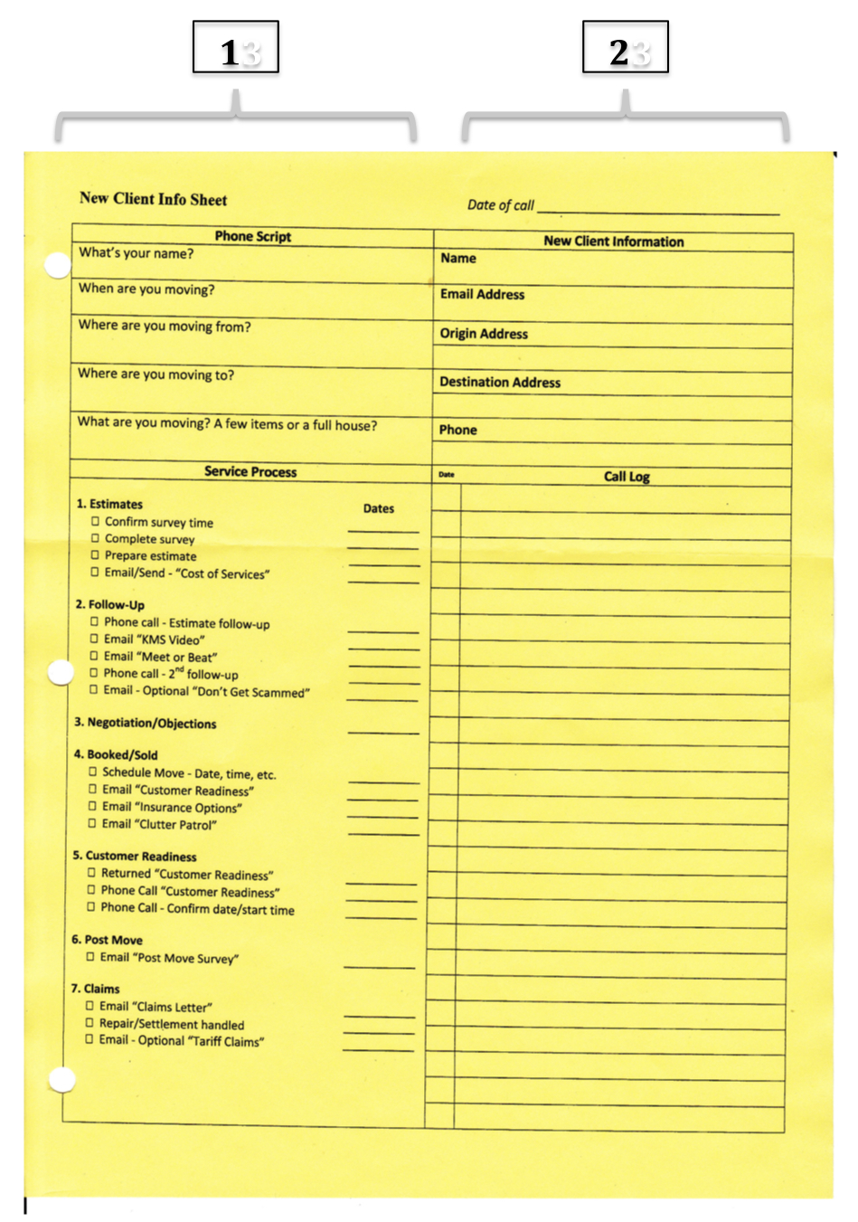

The Survey of Relocation Services (Orange)
The estimator fills in information on this document during the in residence survey, in the car after the estimate, or after returning to the office. While in the residence fill in the Customer Information, General Information, Origin Information and Services, and Destination Information. Wait until you are in the car to fill out the Other Information and CR (customer relations) sections.

After doing the furniture and carton tally sit at a table or stand at a counter with the customer to fill out this sheet. Simply go through each section step-by step with the customer. Answer any questions they may have in the process. One exception is that the Crates section should be filled in during the survey while tallying the furniture and cartons.

The sections titled Other information and CR should be completed in the car afterwards. These sections contain professional and personal assessments about the customer that should be kept private between the estimator and the KMS office. If you are not able to complete these sections immediately in the car you may finish these at the KMS office or your home office.

Some terms on the Survey of Relocation Services Sheet (Survey Sheet) may need some definitions. Some of them include the following:
(See following page for diagram with corresponding numbers)

1. Customer Information section:
Destination Contact is any unique or different contact information needed
where the load is to be moved.

2. General Information section
House-Bedrooms_____________ Type______________ :Number of bedrooms and
type is number of floors or levels
Apartment Bedrooms Floor: What floor the apartment is on
Requests Valuation Information: This means insurance, Justin will write
more
Extra Pickup: A second location to pickup items
Extra Delivery: A second location to deliver items

3. Origin Information and Services
Truck Accessibility: Is there a long drive, can a semi get within 75ft
Difficult Clearances: need to know if in cul de sac, any other difficulties
Difficult Basement Items need to know if in cul de sac, any other difficulties
Difficult Second floor Items: Pianos, Pool Tables, Large Freezer, Gun Safe
Excessive Distance: note any distance over 75ft
Flights of Stairs Steps Outside Inside: note flight over five steps
Pool Table Number of pieces of slate: most slate table have three sections,
some have one very large one, note either way
Crates: measure length, width, height adding one inch to each dimension
LxWxH mean Length times Width times Height
Bulky Articles: Hot Tub, Riding Lawn Mower, Boat, Playground Equip

4. Destination Information
House Bedrooms Type: Number of Bedrooms and number of floors
Apartment Bedrooms Floor: Number of bedrooms and what level
5. Other Information
Recommended Truck: Justin add here
Small Delivery Justin add here
Straight Justin add here
Semi Justin add here
Additional Information Justin add here
COD: The customer pays at destination right after finished
NAT ACCT: Paid through an account with Atlas
Need Weight: Not Applicable
Need Inventories: If customer needs items to be tagged note this
6. CR
Customer Description: make a judgment
Customer Organization: mark cluttered only if it will slow down moving
Overall Job Difficulty: make a judgment

(See Section Explanations according to number on following page)

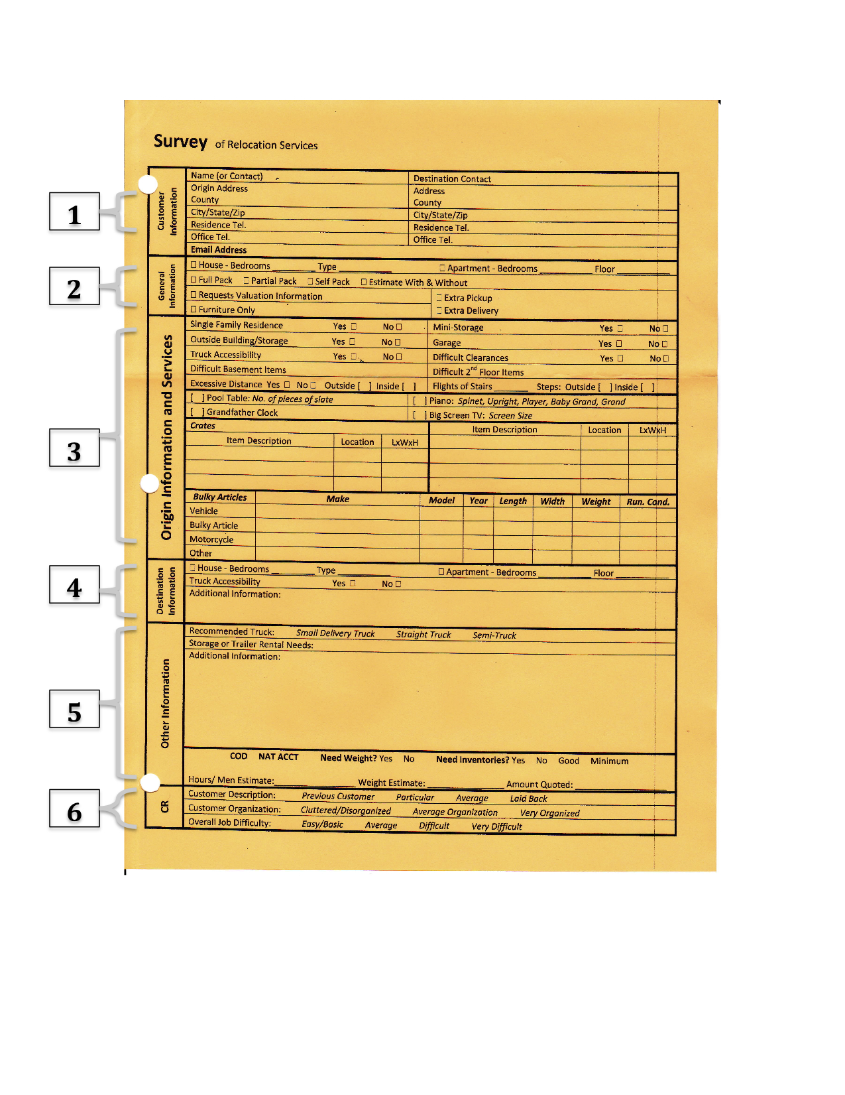

The Table of Measurements Sheet/Cube Sheet (White paper, legal length)

The Table of Measurements Sheet is the most detailed and critical document in the customer file. It is also called the ‘Cube Sheet’ because it is used to figure the cubic feet amount of the move.

On the Table of Measurements Sheet you must:
-Know each section and subsection well
-Know how to correctly tally on this sheet during the estimate house survey
-Find each item quickly without searching
-Tally items accurately while customer is talking to you and background
noise from the residence is present (dogs, kids, TV, etc.)
-Total all columns accurately and transfer totals to the bottom right section
for the final summary (this process is called ‘cubing’)

Basically, the estimator must know every part of this document, what each section and item is for, and how to calculate totals and summarize the information without error. The sale is made or lost based on the accuracy of the Table of Measurements.

Overall Purpose of the Table of Measurements
(Called the TOM from now on)

The purpose of the TOM is to determine the total cubic feet and weight of all items to be moved. This includes all furniture and large bulky items such as vehicles and pianos. Also this includes all items packed into cartons both by the owner and by Kearney Moving. And this includes any large miscellaneous items that must be crated. Finally, the amount of cartons needed from Kearney Moving must also be estimated.

This is the process summarized: (order may change slightly from job to job)
1. Tally number and type of furniture items
2. Tally number of cartons already packed by the customer
3. Tally number cartons that need to be packed by Kearney Moving
4. Determine dimensions of large items to be crated
5. Multiply tallies for all furniture and cartons according to the industry
average provided next to the item on the TOM
6. Total cubic feet from the above figures
7. Total weight for estimated cubic feet by multiplying total cubic feet times
seven pounds (industry average for cubic foot of movable items)
8. Total number of empty cartons to be packed by Kearney Moving

Sections of the TOM Explained

Name of Customer: This is very important to fill in, there is no way to know what residence TOM goes to if papers got mixed up somehow.

1.
(Notice that the top section is divided into three main columns each with the following headings.)

Disassembly: Tally in this column next to any item that requires disassembly.
(typical items are beds, cribs, kitchen table, mirror chest, trampolines)

Article: Almost all household items you will see are listed according to room

No. of Pieces: Tally the number of the items listed in the article column

Cube: This is the industry average number of cubic feet for the item in the article
column
Total Cube: Each row in this column is the number of tallies for each article times the cube number.

2.
List of furniture items: Almost all household items you will see. This is divided into three columns

3.
Column Totals: The two empty squares to the right of ‘Total Column 1’ will contain in the first square the sum of the number of pieces. The second square will contain the sum of the total cubes. Fill in the similar squares for ‘Total Column 2’ and ‘Total Column 3’ the same way.

4.
Origin: This is for difficult corners and stairs at the residence before the move, put brief description in square as needed. This includes tight stairways, 90-180 degree turns, narrow hallways.

Destination: This is for difficult corners and stairs at the destination of the move, put brief description in square as needed

Difficult Basement or 2nd Floor Items: List and briefly describe items such as pianos, large wardrobes, gun safes, etc. that must pass through tight turns, hallways, carried up from basement or down from 2nd floor.

5.
Carton: This column lists all types of cartons needed
See Crates at the bottom of this column. Kearney Moving almost never needs to crate items for a local move. But if it is necessary manually calculate and put totals here.

Note Justin check this: To the left of each carton size put the actual number of cartons that were tallied on the right from the Carrier Pack column only. Because when figuring the estimate this will determine the amount to charge for packing labor and supplies.

Carrier Pack: Tally cartons that need to be provided and packed by Kearney Moving. This must be at customer request.
Owner Pack: Also called “PBO’s” (packed by owner.) Tally only cartons that have been already packed by the customer
Total Ctn: Each row under Total Carton is the sum of the tallies in Carrier Pack and
Owner Pack
Cube: This is the total cubic feet for the size of the carton
Total Cube: For each row multiply the numbers in the Total Carton Column by the amount in the Cube Column.

6.
XXXXXXXXX’s: These X’s make sure that only Carrier Pack and Owner Pack numbers are tallied. Mattress cartons are calculated differently and are taken care of by the office staff not the estimator. From the estimator we want to know how many boxes are needed, but not the cubic feet of mattresses. That info for mattresses is already calculated in the bedroom section above.

7.
Total: The first square to the right of ‘Total’ is the sum of the numbers in the ‘Total Ctn.’ Column. The second square to the right is the sum of the numbers in the ‘Total Cube’ Column

8.
Total Column 1: Transfer the totals from ‘Total Column 1’ at the bottom of the first column in section 2.
Total Column 2: Transfer the totals from ‘Total Column 2’ at the bottom of the second column in section 2
Total Column 3: Transfer the totals from ‘Total Column 3’ at the bottom of the third column in section 3.
Total Cartons: Justin explain. I think it goes like this. The Total Carton’s first square to the right is the number from the Total Ctn. Column Total at the bottom of the Carton section. The Total Carton’s second square to the right is the number from Total Cube Column Total at the bottom of the Carton section.

TOTAL CUBE: Justin explain. The first square to the right is the sum of PCS column above. The second square to the right is the sum of the CUBE column above

Wt. Factor (lbs./cu. ft.): The industry standard is seven pounds per cubic foot. So simply place 7 on this blank (unless instructed otherwise)
Computed Est. Wt.: Multiply TOTAL CUBE amount from second square to the right times seven.
TOTAL EST. WEIGHT: Not to be filled by estimator, sales manager will take care of this.

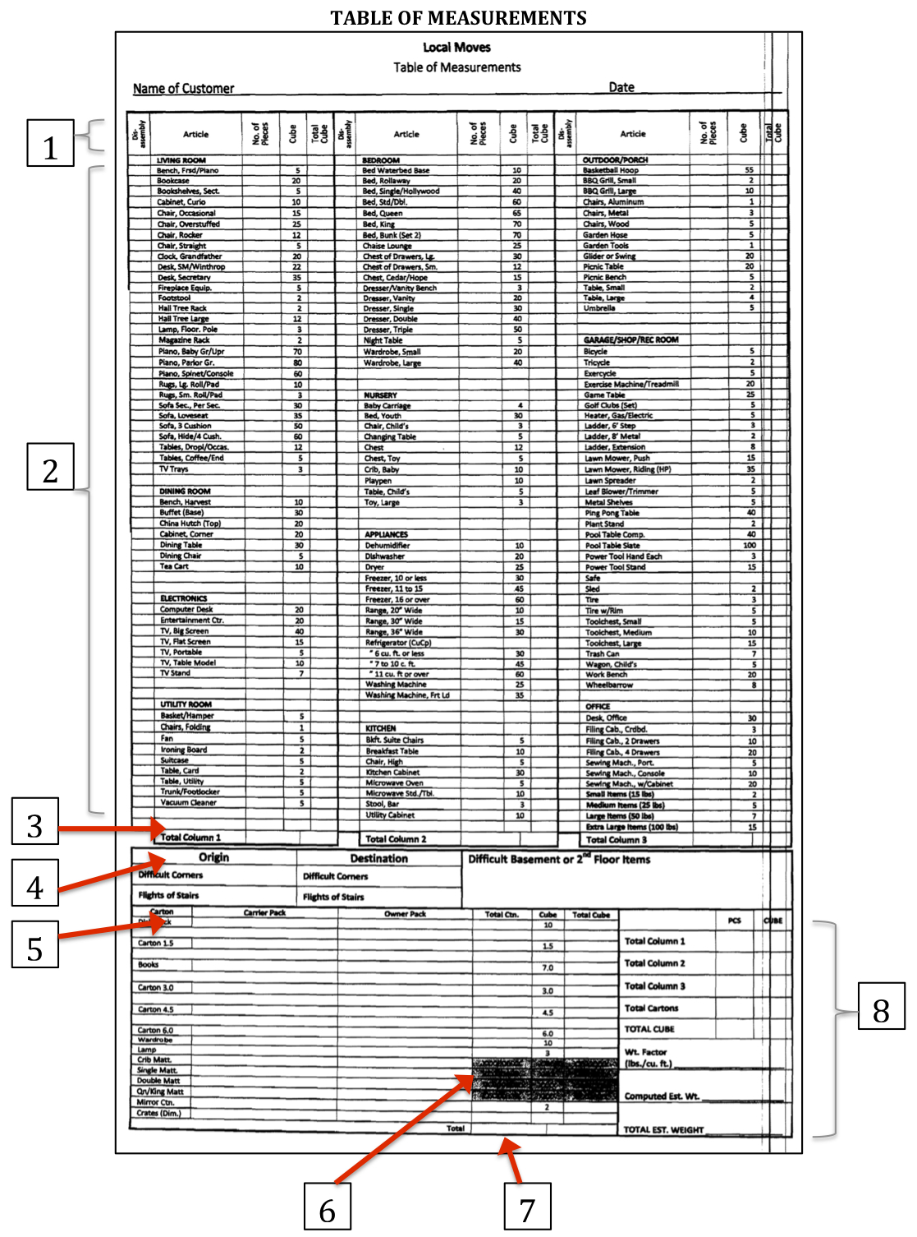

Example of Completed TOM/Cube Sheet
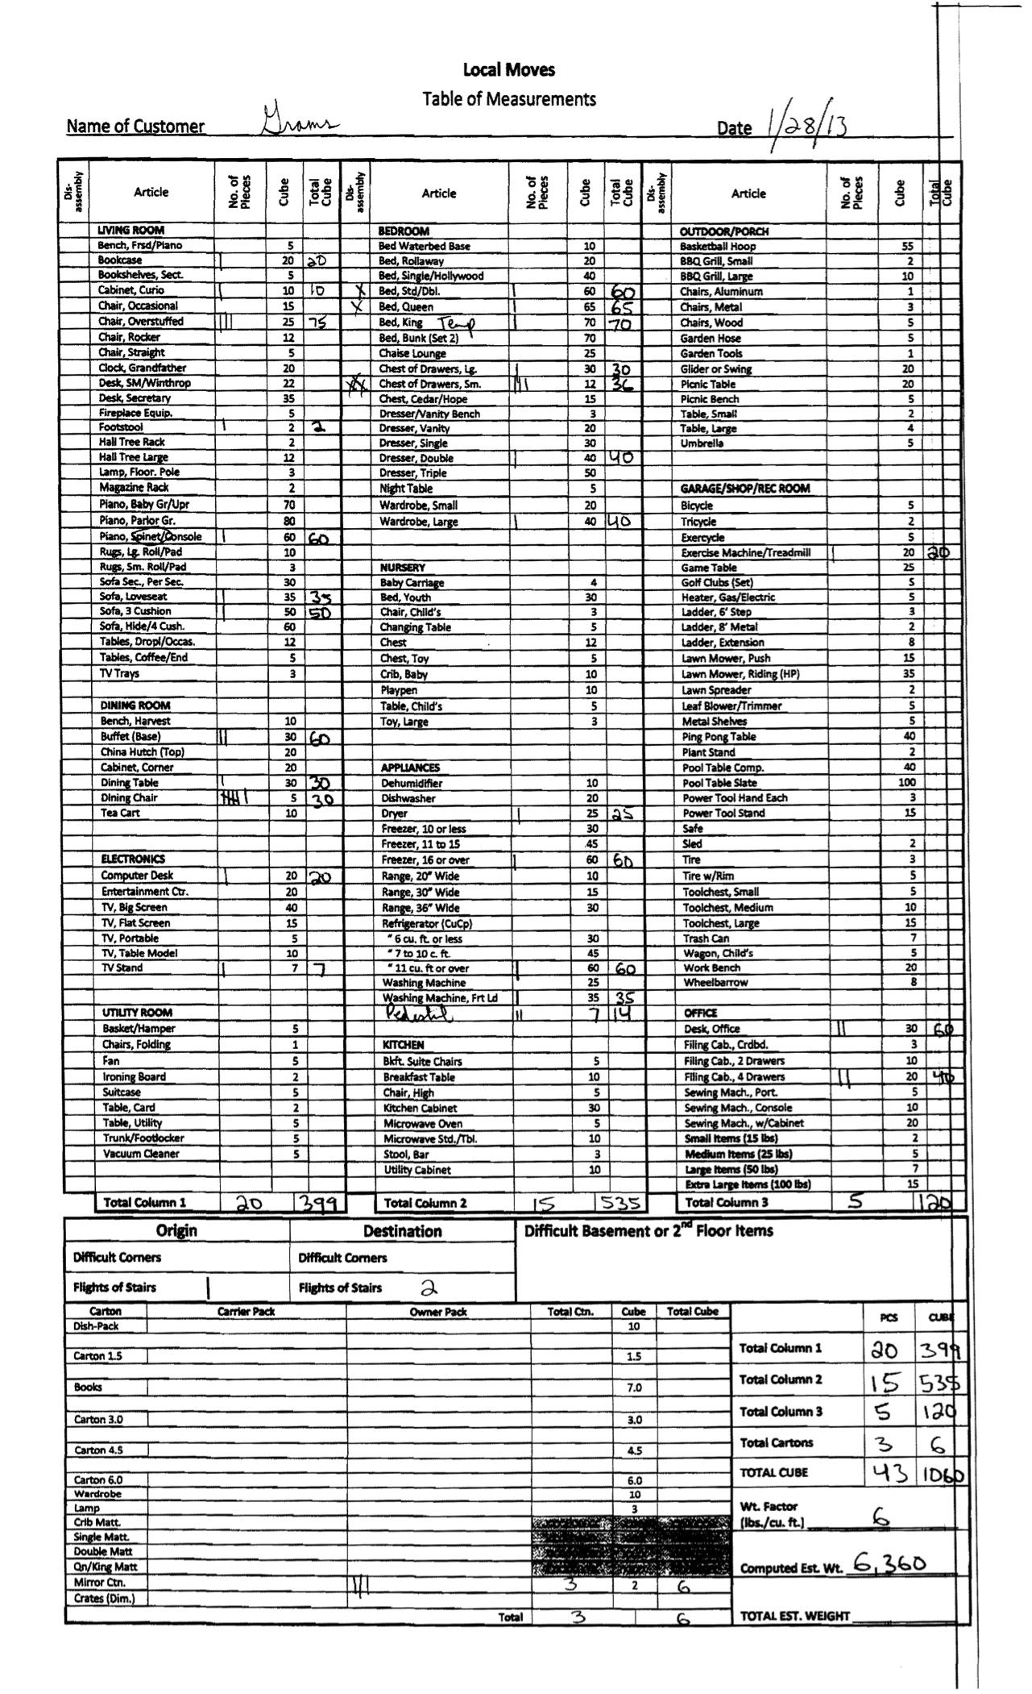

How to Place Tallies on the TOM

You may want to get a copy of a TOM while ready this section.

When you enter room and begin going around estimating furniture, place a tally for each item in the column titled ‘No. of Pieces’ directly to the right of the article. If the item requires disassembly put an X or tally directly to the left of the article in the column titled ‘Disassembly.’

When you begin going around the room estimating cartons remember you are entering PBO’s (cartons already packed by owner,) and CP’s (cartons that are Carrier Packed by Kearney Moving.) Tally the PBO’s two columns to the right (titled ‘Owner Pack’) of carton listed. Tally the CP’s one column to the right (titled ‘Carrier Pack’) of the carton listed.

